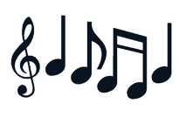
*love *dreams *beautiful *kids *kiss *heart *secrets *arms *song *perfect *man *beautiful *hand *angel *eyes *girl *perfect *dress

+kiss
Listen to the song “Perfect” and fill in the gaps with the words from the box.ox.

Well I found a 9. __________, stronger
than anyone I know
He shares my 10. _______________,
I hope that someday we'll share a home
I found a love, to carry more
than just my 11. ____________
To carry love, to carry
children of our own

We are still kids,
but we're so in love,
fighting against all odds
I know we'll be alright this time
Darling just hold my 12. _________,
be your 13. __________, you'll be my man
And I see my future in your 14. ________

Well baby I'm dancing in the dark,
with you between my arms
Barefoot on the grass,
while listening to our favourite song
When I saw you in that 15. _______,
looking so 16. __________
I don't deserve this,
darling you look 17. ________ tonight

I found a 1. ________for me
Oh, darling just dive right in and follow my lead
Well I found a girl, 2. __________and sweet
Oh, I never knew you were the
someone waiting for me
Cause we were just 3. __________when
we fell in love
Not knowing what it was,
I will not give you up this time
Darling just 4. ________ me slow,
your 5. _________ is all I own
And in your eyes you're holding mine

Baby I'm dancing in the dark,
with you between my 6. _________
Barefoot on the grass, while
listening to our favourite 7. _________
When you said you looked a mess,
I whispered underneath my breath
But you heard it,
darling you look 8. ________ tonight
Baby I'm dancing in the dark,
with you between my arms
Barefoot on the grass,
while listening to our favourite song
I have faith in what I see
Now I know I have met an 18. ________ in person
And she looks perfect, I don't deserve this
You look perfect tonight

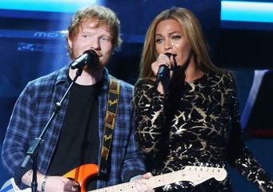



Music “Perfect”,
by Ed Sheeran & Beyoncé

