Greece
Greece is a country located in Southeast Europe and is situated on the southern tip of the Balkan Peninsula. Its population is approximately 10.7 million and the capital is Athens the largest city,follow by Thessaloniki. Greece has the longest coast line on the Mediterranean Basin and has many islands of which 227 are inhabited. It has also many mountains, with Mount Olympus being the highest peak. 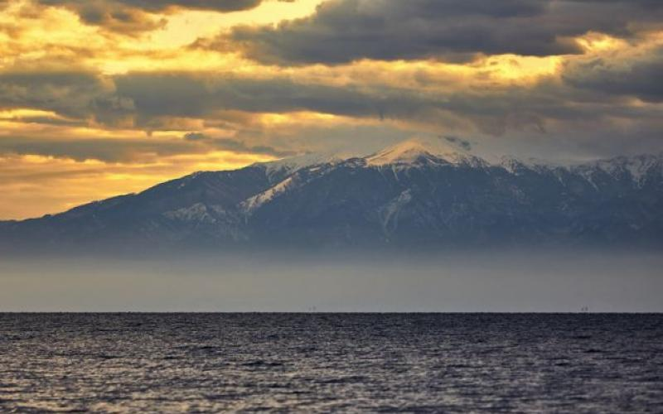
The country consist of nine traditional geographic regions Macedonia, Central Greece, the Peloponnese, Thessaly, Epirus, the Aegean Islands (Dodecanese and Cyclades), Thrace, Grete and the Ionian islands. Greece is considered the cradle of western civilization, being the birthplace of Democracy, philosophy, literature, historiography, political science, major scientific and mathematical principles, drama and the Olympic Games.
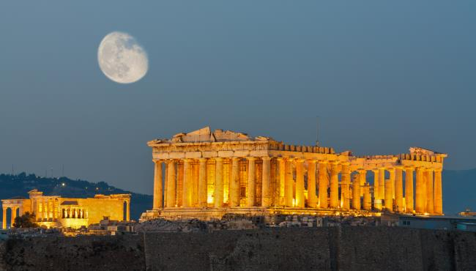
Greece is a beautiful country that is visited by many people for its seas and islands but also for its ancients and museums. You can visit the Parthenon, the Epidaurus,the archeological museum in Athens, the oracle of the dolphin, the white tower in Thessaloniki, Virginia and much more.
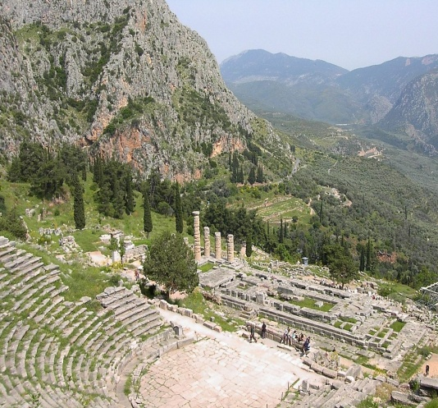
I am very proud to live in Greece and I recommend to the people to visit this beautiful country.
